Student’s Name
Professor’s Name
Course Number
Date
Flyer on Racial Discrimination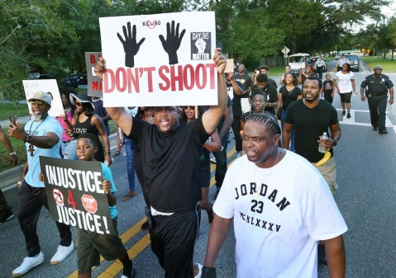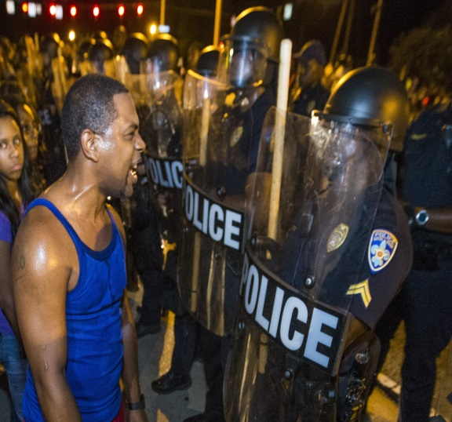
HELP IN THE FIGHT AGAINST RACIAL DISCRIMINATION IN THE U.S.A!
Racism: It Stops With Me.
We are one regardless of the Color on our
-Skin. One America, One People.
Website: www.stopracism.org
Email:stopracism@yahoo.com
Black Lives Matter!
Racism is a social menace plaguing the US, and the vice occurs to various individuals on a day-to-day basis, it has thrived in our silence, but it is high time we eradicate it. Racial hatred propagates discrimination of persons based on the color on their skins. Racial intolerance leads to the violation of human rights of the minorities especially the Black community (United Nations Human Rights). The United Nations stipulates that discrimination of humans based on their racial orientation denies them their fundamental human rights and freedoms. There ought to be proactive measures to stop extra-judicial killings on the people of color to promote justice as enshrined in our constitution. The "Black Lives Movement" movement aims to prevent the brutality and unfair treatment of the Black community by the law enforcement officers (Black Lives Matter). We are all protected under in our constitution, and the rule of law should apply regardless of your race. The fight against racism requires collaborative efforts; therefore, it starts with you and me.

References
Black Lives Matter. Black Lives Matter global network releases a video to commemorate our 5TH anniversary. Retrieved from https://blacklivesmatter.com/pressroom/black-lives-matter-global-network-releases-video-to-commerate-our-5th-anniversary/
United Nations Human Rights. Combating racial discrimination. 2019. Retrieved from https://www.ohchr.org/EN/Issues/Discrimination/Pages/discrimination_racial.aspx Image 1.
Riddell, Kelly. The lies of Black Lives Matter. The Washington Times. 18TH July, 2016. Retrieved from https://www.washingtontimes.com/news/2016/jul/18/lies-black-lives-matter/ Image 2.
Goldstein, Diane. I am a White cop and I support Black Lives Matter. Vice Channels. 12TH July, 2016.Retrieved from https://www.vice.com/en_us/article/mvkjma/white-cop-black-lives-matter

